
LESSON NOTE | DETAILED EXPLANATORY NOTES
BIONICS & ROBOTICS
SENSORY SYSTEMS (FOR ROBOTICS)

GRADE 12 - BIOLOGY
■ ■ ■

From Biology to Robots
For a robot to act intelligently, it must first sense its surroundings - just as living things do. Engineers have copied the body's sensory systems to give robots artificial 'senses'. A robot's sensors detect signals such as light, sound, distance, touch and temperature, convert them into data, and pass them to a processor that decides how to act. This is the same three-step pattern found in biology: detect a stimulus, process it, and respond.
This lesson shows how biological senses map onto robotic sensors, how a robot's sensing pipeline works, and the main types of sensor used in robots. It connects the neurophysiology of the earlier lessons - receptors, transduction and integration - to modern robotics and biomimicry.
Why This Matters
- Robots must sense the world before they can act on it.
- Robotic sensors are modelled on biological receptors.
- Sensing shows biomimicry - copying nature to solve problems.
- It links biology with engineering and technology.
Sensory Systems (For Robotics)
Key Learning Outcomes
By the end of this lesson, students should be able to:
- Explain why robots need sensory systems.
- Match biological senses to their robotic sensor equivalents.
- Describe the sensing pipeline: detect → convert → process → act.
- Identify the main types of robot sensor and what they detect.
- Relate robot sensing to transduction and integration in biology.
Biological Senses and Their Robotic Sensors
Every human sense has a robotic equivalent. The eye becomes a camera or LiDAR (which uses laser light to measure distance); the ear becomes a microphone; the skin's touch receptors become pressure and force sensors; the nose becomes a gas or chemical sensor; and the body's balance sense becomes a gyroscope or IMU (inertial measurement unit). In each case, engineers have studied how a biological receptor detects a stimulus and built a device that does the same job - a clear example of biomimicry, or copying nature.
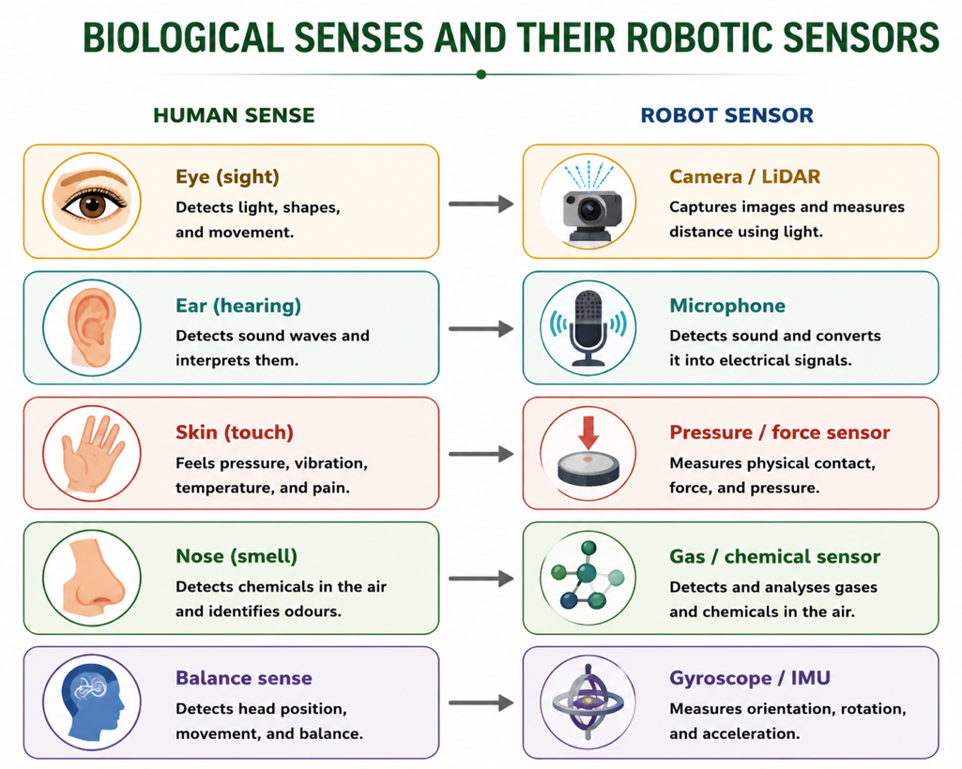
Figure 1: Each human sense has a matching robotic sensor - a clear example of biomimicry.
Terminologies and Concepts
Useful terms for this topic:
- Sensor: a device that detects a physical signal and converts it to data.
- Biomimicry: designing technology by copying nature.
- LiDAR: a sensor that uses laser light to measure distance and build a 3-D map.
- IMU: an inertial measurement unit that senses movement and orientation (like balance).
- Transduction: converting a stimulus into a signal - in biology and in sensors.
- Actuator: a motor or device that produces the robot's movement (its 'muscle').
- Processor: the robot's 'brain' that interprets data and decides.
How a Robot Senses and Responds
A robot's sensory system follows a pipeline that mirrors biology. First, a sensor detects a signal from the environment. Second, the signal is converted into digital data the computer can use (an analogue-to-digital step, like transduction in a receptor). Third, the processor - the robot's 'brain' - interprets the data and decides what to do (like integration in the CNS). Finally, an actuator (a motor) produces the response (like a muscle). So a robot senses, processes and acts using exactly the same logic as a nervous system.
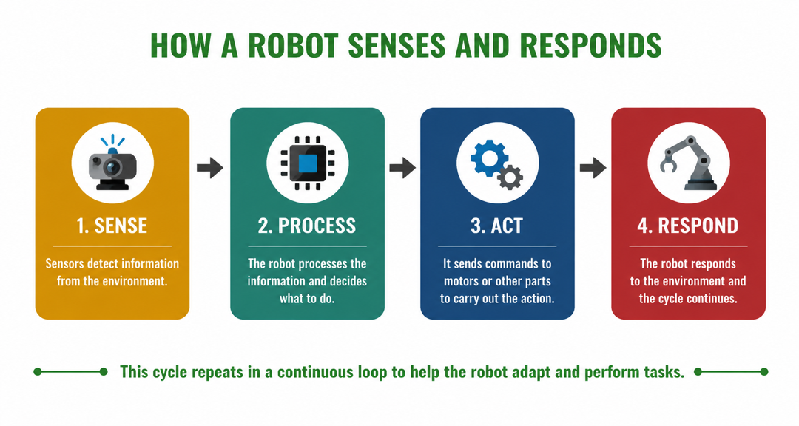
Figure 2: A robot's sensing pipeline - detect, convert, process and act - mirrors the nervous system.
Types of Robot Sensors
Robots use many kinds of sensor, each detecting a particular signal:
- Vision sensors - cameras and LiDAR let a robot 'see' shapes, colours and distances.
- Touch and force sensors - detect contact, pressure and grip, so a robot can hold objects gently.
- Proximity sensors - ultrasonic or infrared sensors measure distance to avoid obstacles.
- Temperature sensors - detect heat, for safety and monitoring.
- Motion sensors (IMU) - gyroscopes and accelerometers track movement and balance.
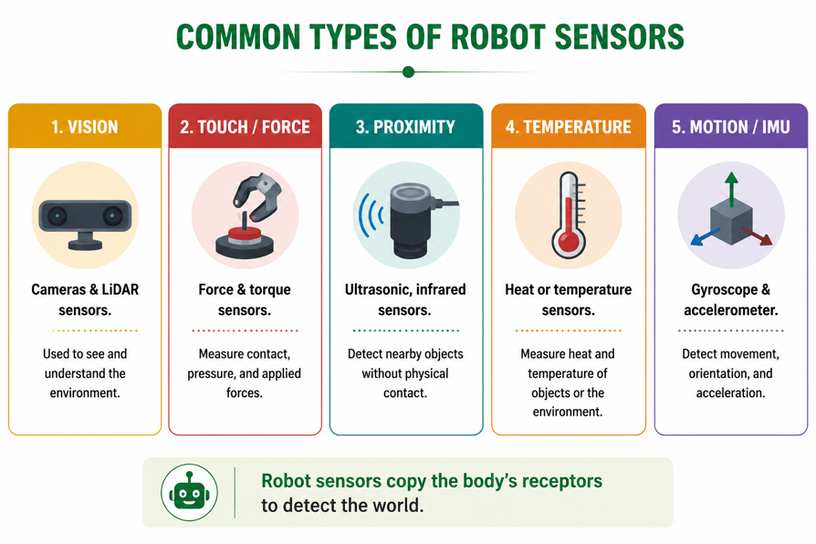
Figure 3: Common types of robot sensor, each copying one of the body's ways of detecting the world.
Sensing Meets Processing - Integration in Robots
Just like the nervous system, a robot must integrate information from many sensors at once. A self-driving vehicle, for example, combines camera, LiDAR, proximity and motion data to build a single picture of the road and decide how to steer - a process called sensor fusion. This is the engineering version of sensory integration in the brain, where signals from the eyes, ears and body are combined into one understanding of the world. The better a robot integrates its senses, the more safely and intelligently it can act.
Why This Matters
- Robotics - sensing is the first step in every intelligent machine.
- Biomimicry - it shows how studying biology drives new technology.
- Everyday tech - phones, cars and appliances use these same sensors.
- Careers - it links biology to engineering, computing and design.
PNG Context Example
Sensor technology is increasingly useful in Papua New Guinea. Drones with cameras and GPS can survey remote terrain, monitor crops, forests and coastlines, and help in disaster response after floods or landslides. Environmental sensors can monitor water quality, volcanic activity and weather. Simple robotics kits with distance and light sensors are also an engaging way for PNG students to learn how biological senses inspire technology - connecting the biology of receptors to real engineering skills and future careers.
References & Related Documents
Source Documents
- STEM Biology Syllabus - Grade 12. Thema: Bionics & Robotics; Module: Sensory Systems (for robotics). Department of Education, PNG.
- Biology Standards-Based Syllabus, Grades 11 & 12 (PNG SBC 2020) - Strand 2: Life; investigate how sensory systems detect stimuli, and relate biological design to technology.
Further Reading & References
- OpenStax Biology - Sensory Systems; Types of Receptors (as a model for sensors). https://openstax.org/books/biology
- Khan Academy - Sensors and how machines perceive. https://www.khanacademy.org/computing

